A Study of Blockchain Technology in Farmer's Portal

Blockchain is a method in which a confirmation of a transaction is kept by means of a crypto-currency. The record is maintained transversely, linking several computers in a peer to peer network. Contracts, transactions, and the records of them define the economic system of a country. They set boundaries and provide security to the assets. Considering the features of Blockchain such as immutability and maintaining the footage of transaction details, this paper highlights the usage of Blockchain technology with farmer's portal that keep the footage of selling and buying information of crops. The proposed solution uses the python as a programming language in integration with the Blockchain system that will benefit the farmers or vendors and individuals by preserving the contract of trade. An interface for the farmers is designed using a python programming language in addition with Blockchain technology, which is used to store the information related to seller, buyer, selling and buying an item and total value transacted.

All existing applications are based on centralized server where single server is responsible to manage all storage and processing and if this server hacked of down then services will not be available and there is no way to know whether server is normal or attacked by attacker. To overcome from this problem Blockchain technology was introduced where data will be stored in Decentralized (data stored at multiple nodes or servers) machines or nodes. Each node will store data as block of transaction and each transaction is associated with unique hashcode and this hashcode will be verified before storing new data or block and if verification failed then Blockchain will get intimation as server is under attack and users may get data from other working nodes. If one node down then users can get data from other working nodes. Due to this decentralized and attack proof features of Blockchain inspired author of this paper to manage FARMER details using Blockchain technology where farmer can add and sale their products or crops and consumer can purchase those crops.

To implement this project we have designed following modules

1. Register Here: using this module both farmers and consumers can signup with the application and all this details will saved inside Blockchain nodes as block and associate each block with hashcode
2. Login: using this module both farmer and consumer can login to application
3. Add Products: using this module farmer can add their crop details with images and quantities
4. Update Quantity: using this module farmer can update quantities of existing crop details
5. View Orders: using this module farmers can view orders from various consumer
6. Browse Products and Book orders: using this module consumer can view list of crops and then book order of desired crops.

Below screen showing Blockchain code to store data with proof of work and hashcode

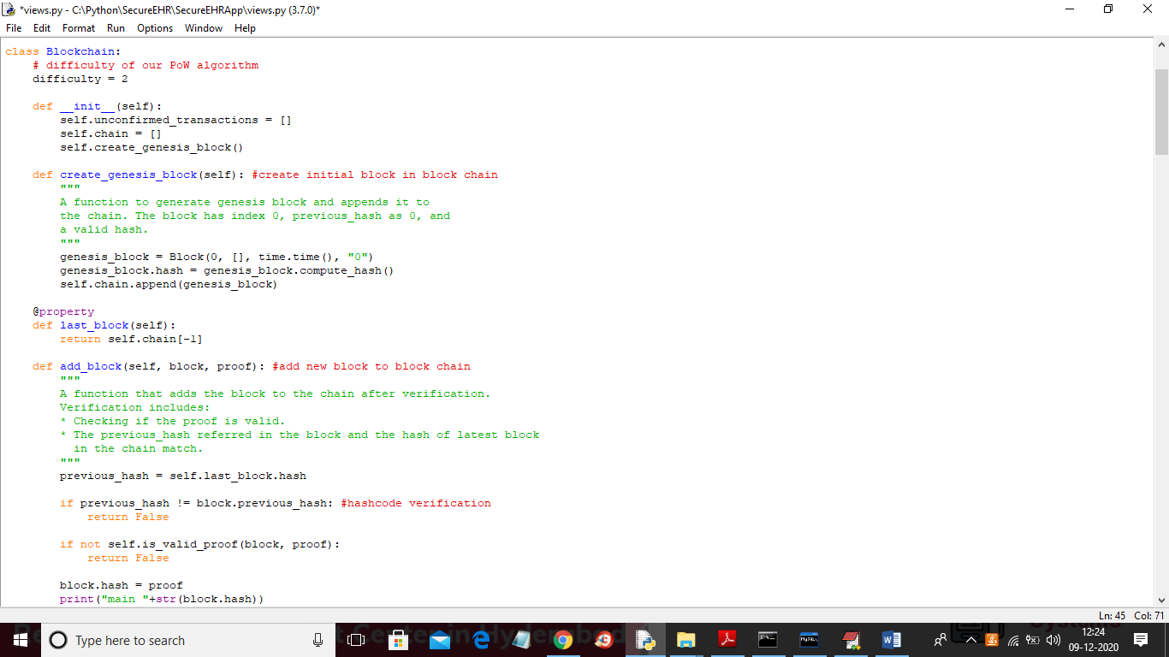

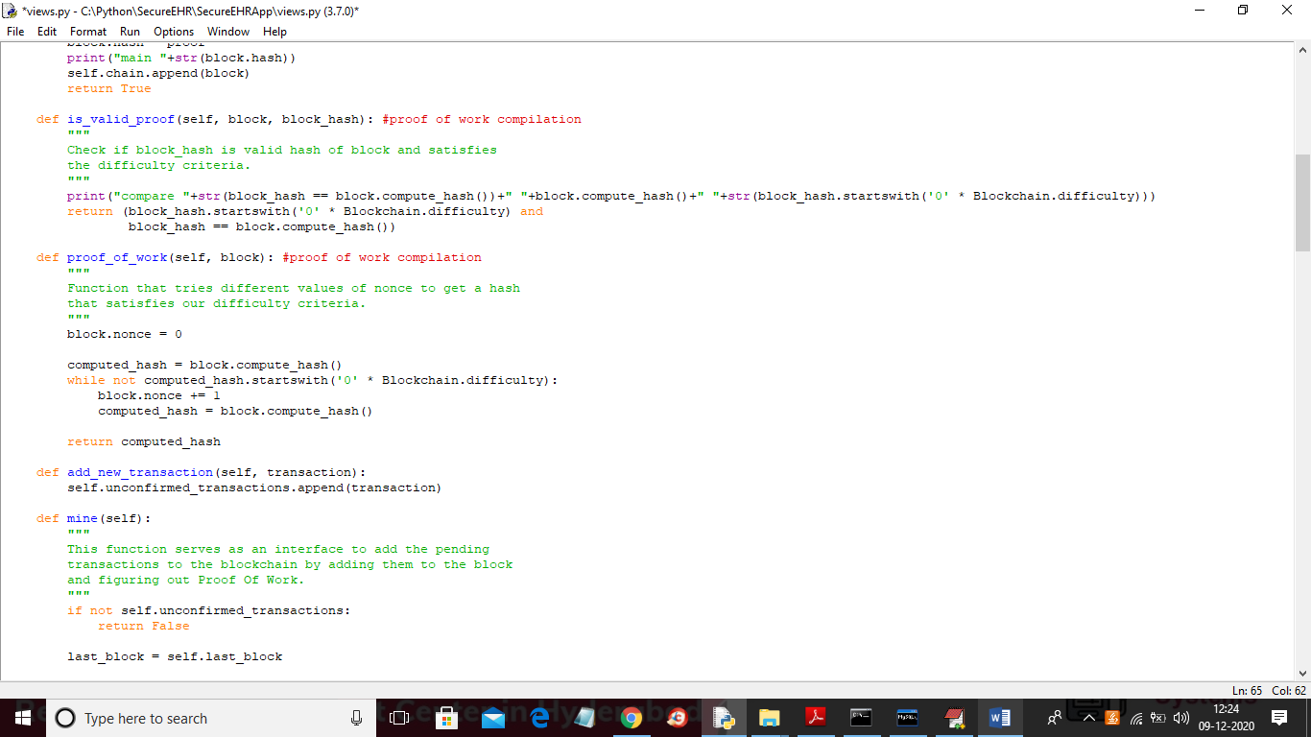

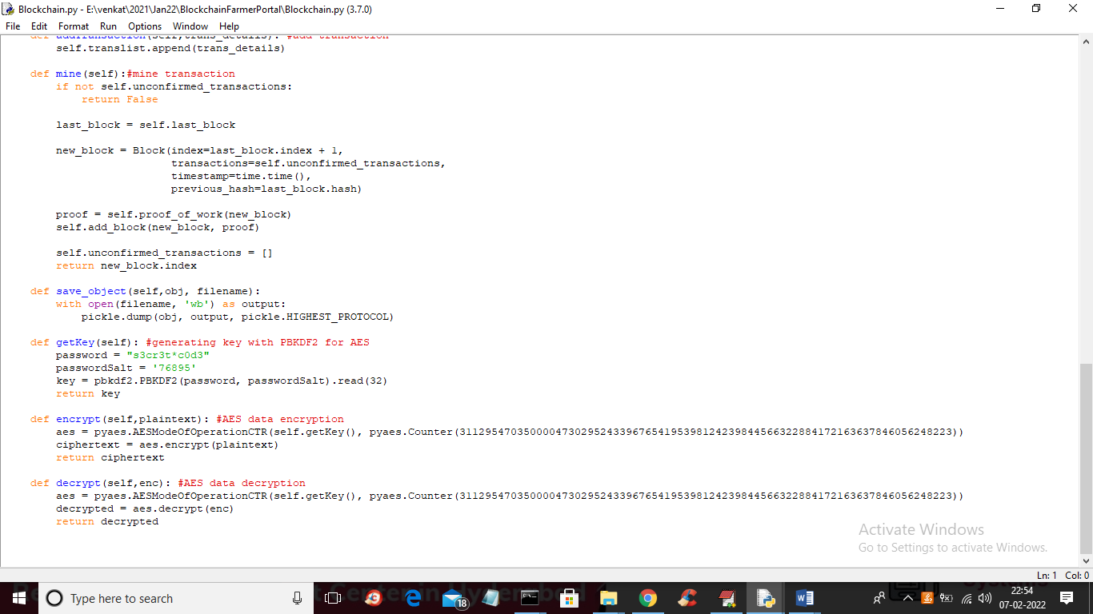

In above 3 screens you can read red and green colour comments to know how Blockchain encrypt data and then store that in blocks with hashcode and then perform proof of work for block verification.

SCREEN SHOTS

To run project install python 3.7 and DJANGO package and then double click on ‘run.bat’ file to start DJANGO server and to get below screen

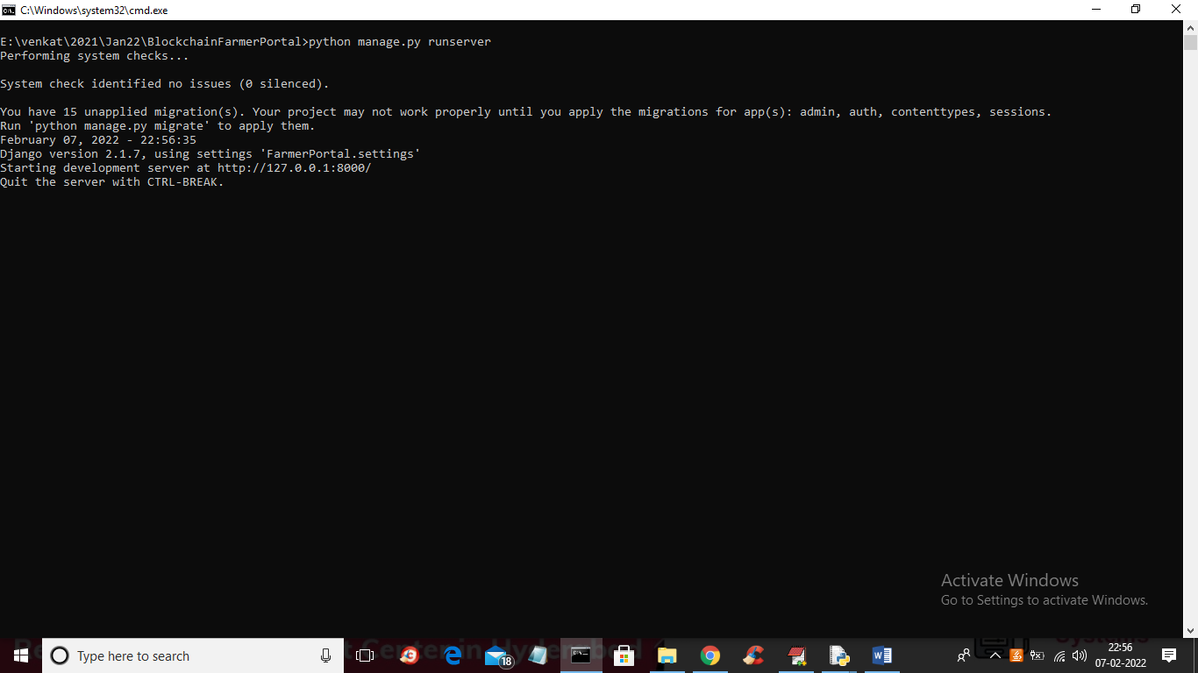

In above screen we can see DJANGO server started and now open browser and enter URL as <http://127.0.0.1:8000/index.html> and press enter key to get below home page

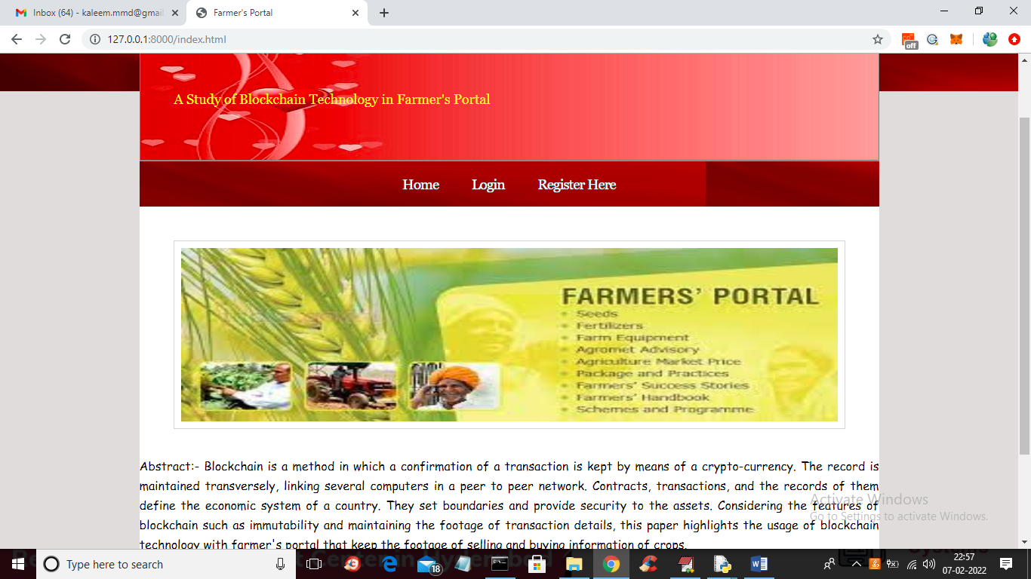

In above screen click on ‘Register Here’ link to get below signup screen

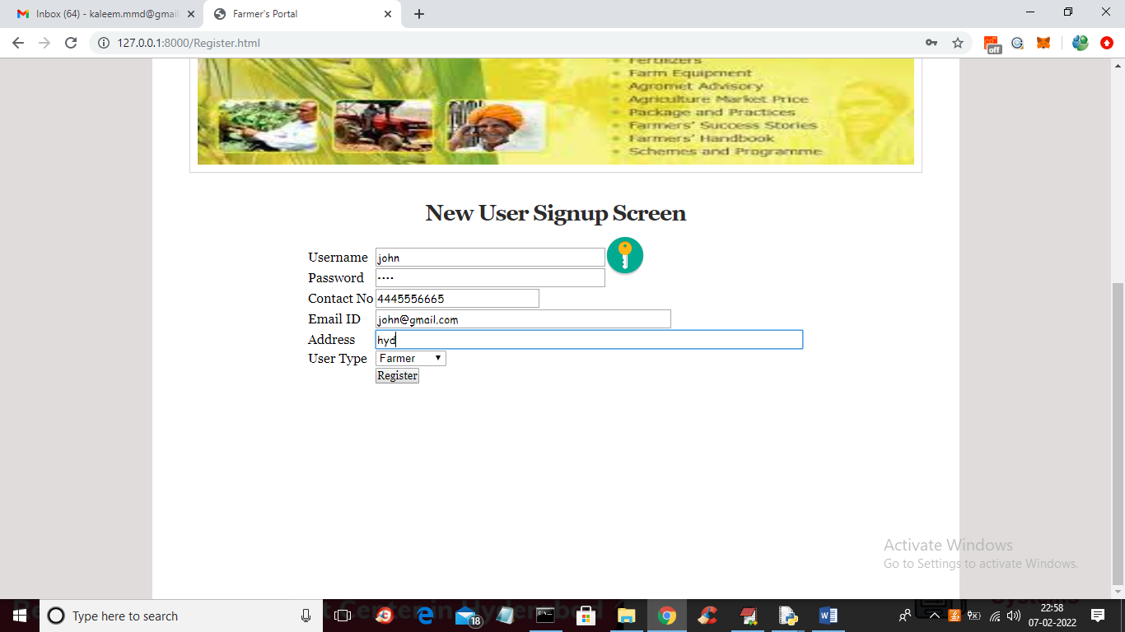

In above screen I am entering signup details and then click on ‘Register’ button to store data in Blockchain and to get below output

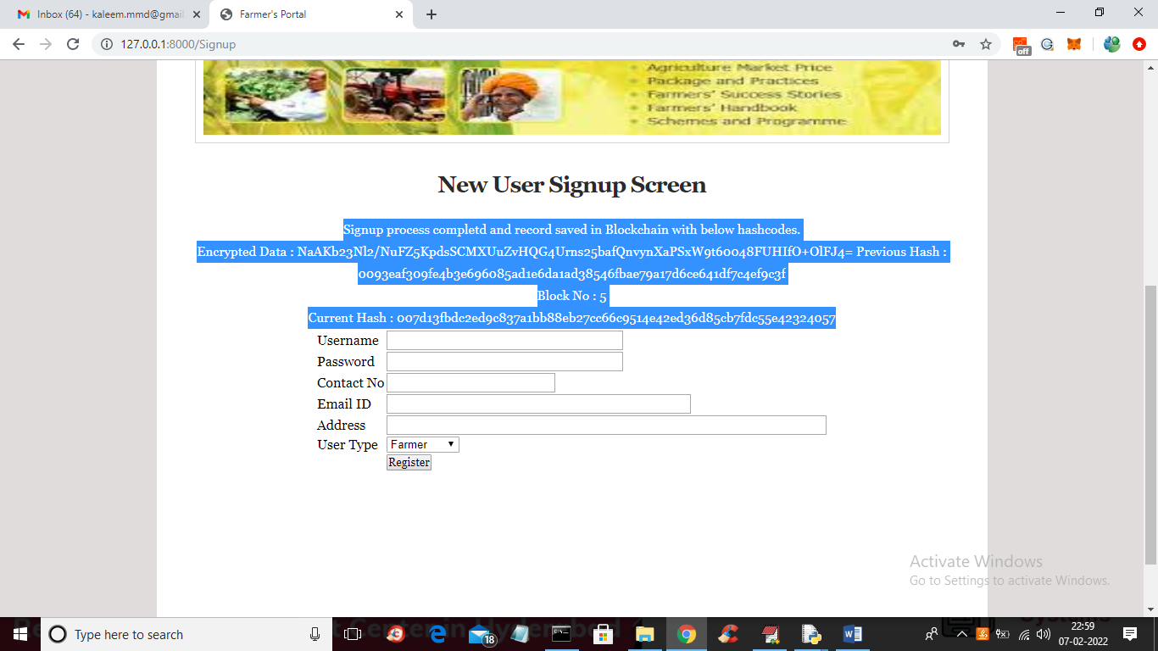

In above screen in blue colour text we can see data is encrypted and then printing block number and previous and current hashcode to which this block data associate and similarly add new consumer also like below screen

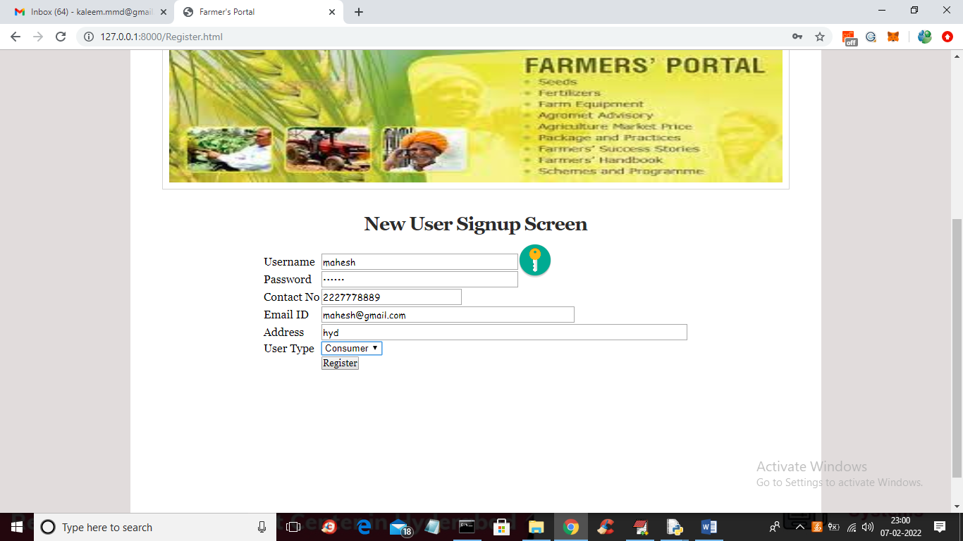

In above screen I selected user type as consumer and then press button to add consumer details and get below output

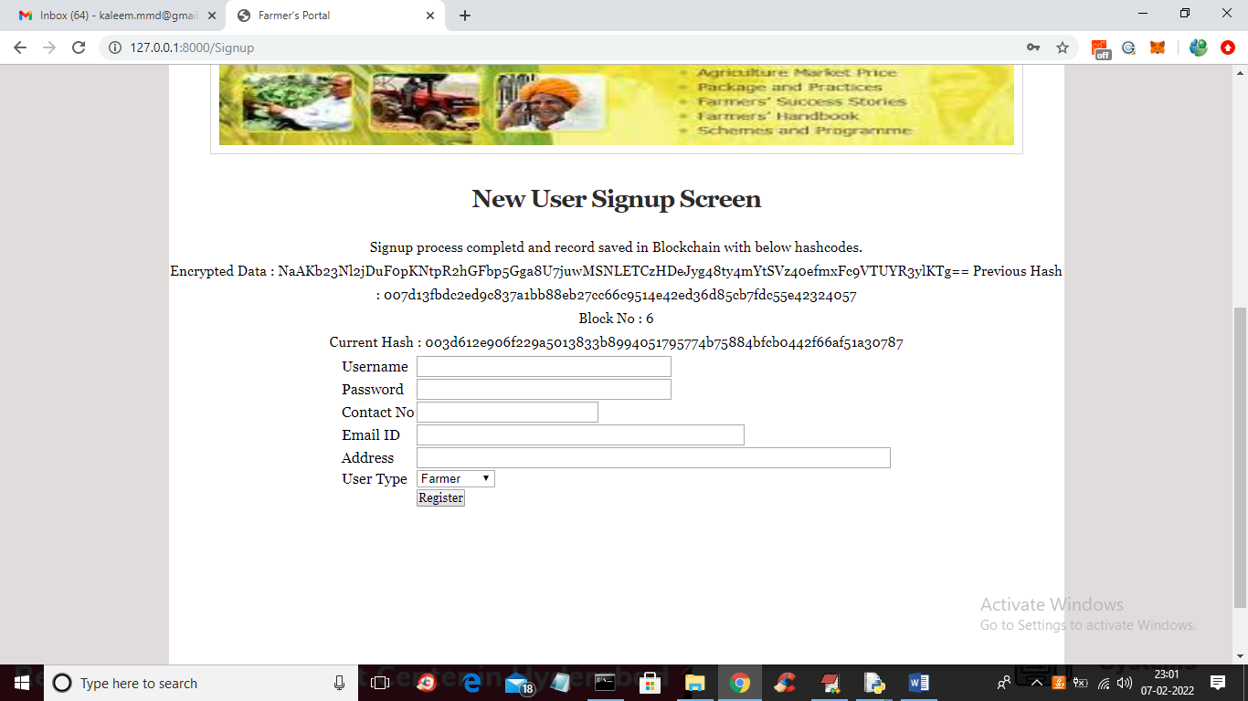

In above screen we can see all Blockchain details and now click on ‘Login’ link to get below screen

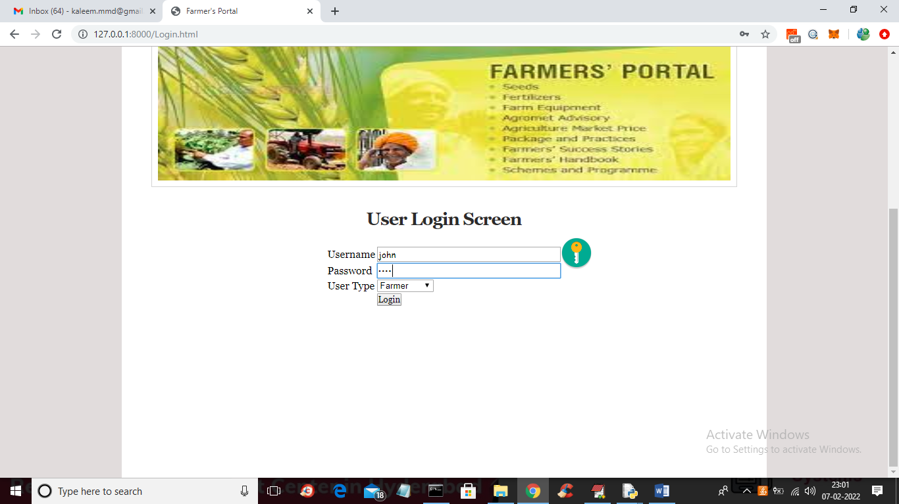

In above screen farmer is login and after login will get below screen

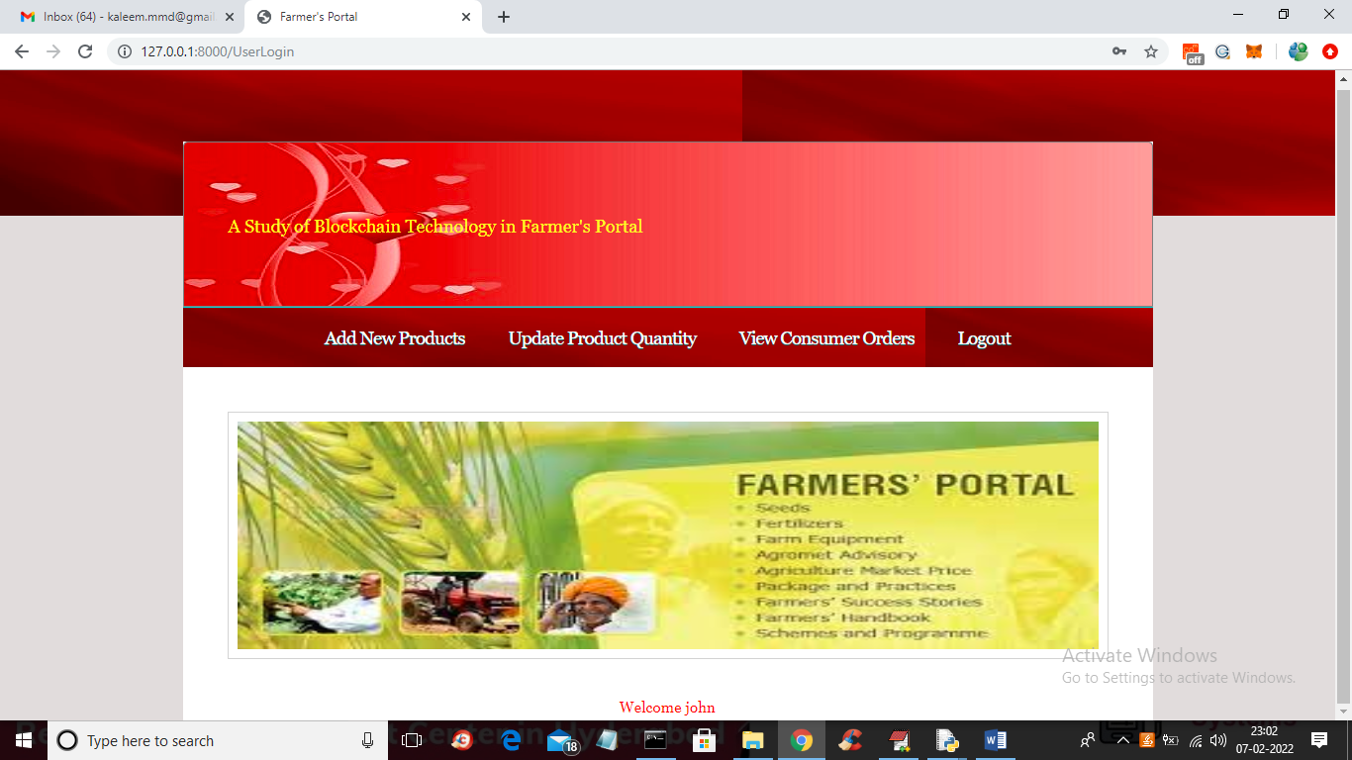

In above screen farmer can click on ‘Add New Products’ link to add new crop details like below screen

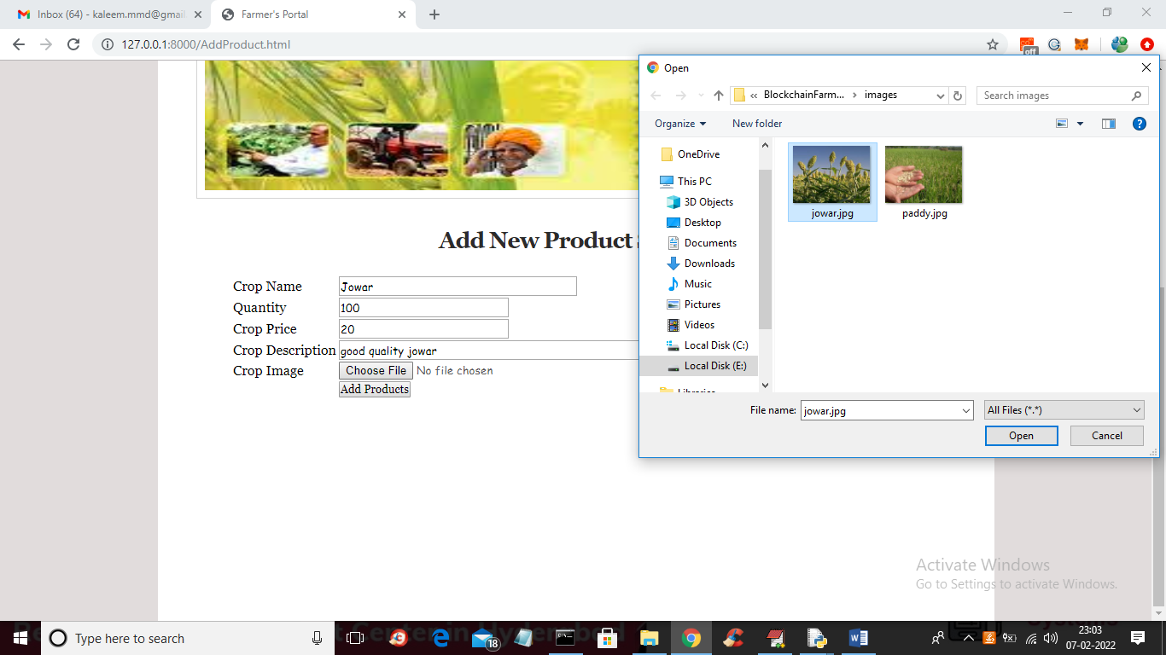

In above screen farmer can add crop details and upload crop image and then click on ‘Add Products’ link to get below output

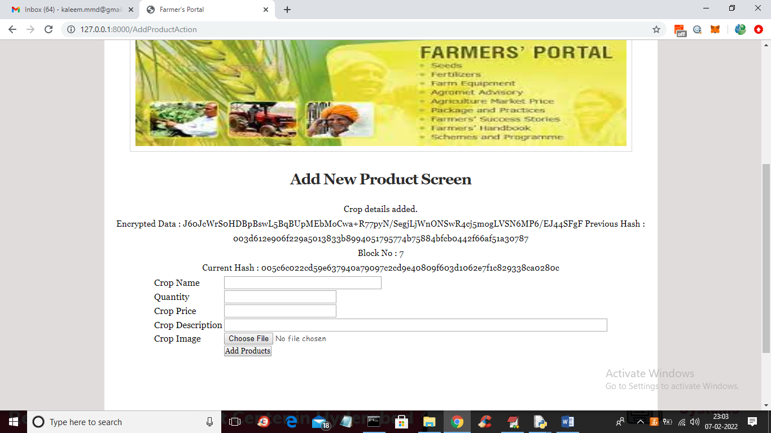

In above screen we can see crop details added and displaying Blockchain storage details and now click on ‘Update Product Quantity’ link to get below screen

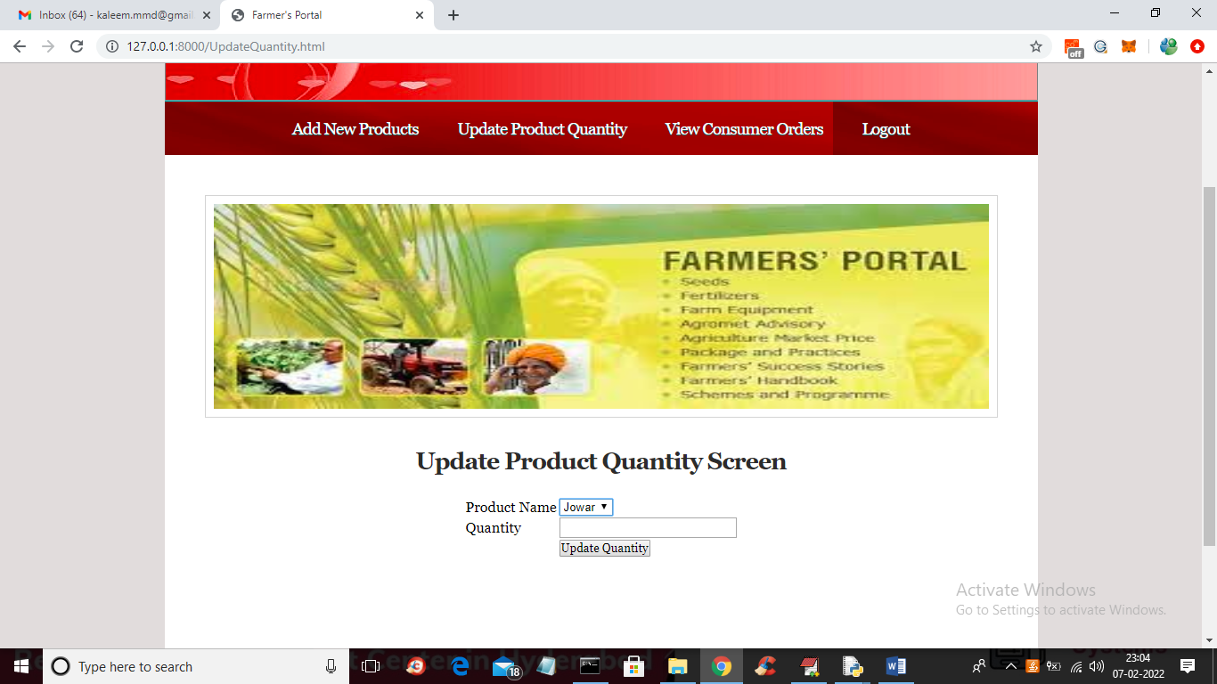

In above screen farmer can select product name and enter quantity value to update quantity like below screen

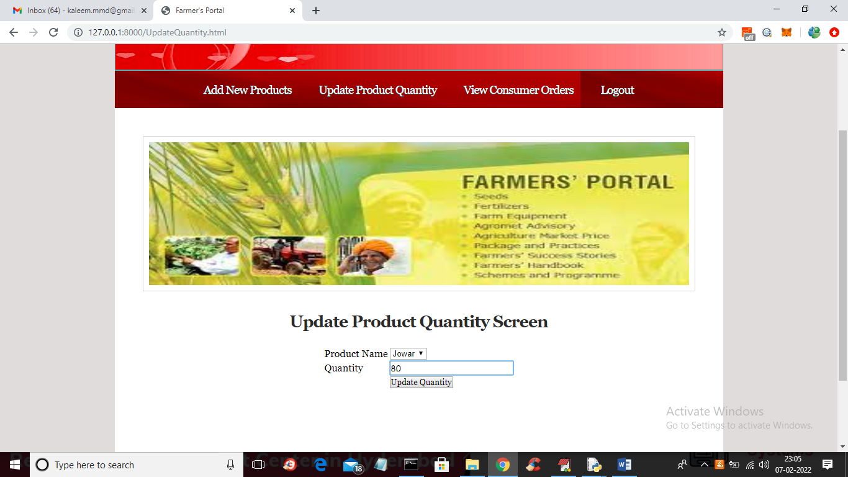

In above screen entering quantity values and then press button to get below output

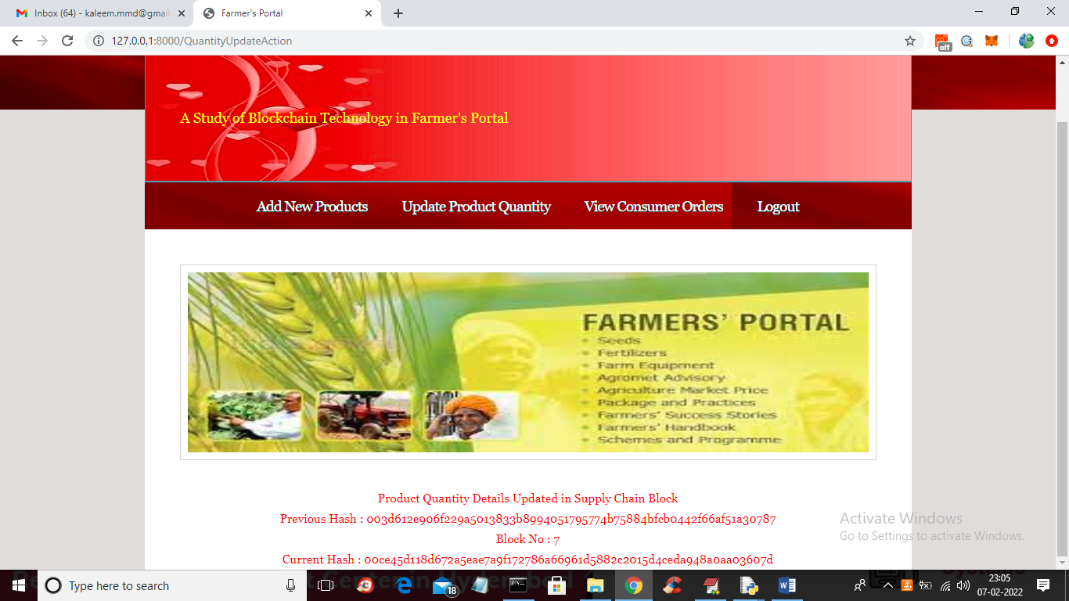

In above screen in red colour text we can see crop quantity details updated and now logout and login as consumer to book order

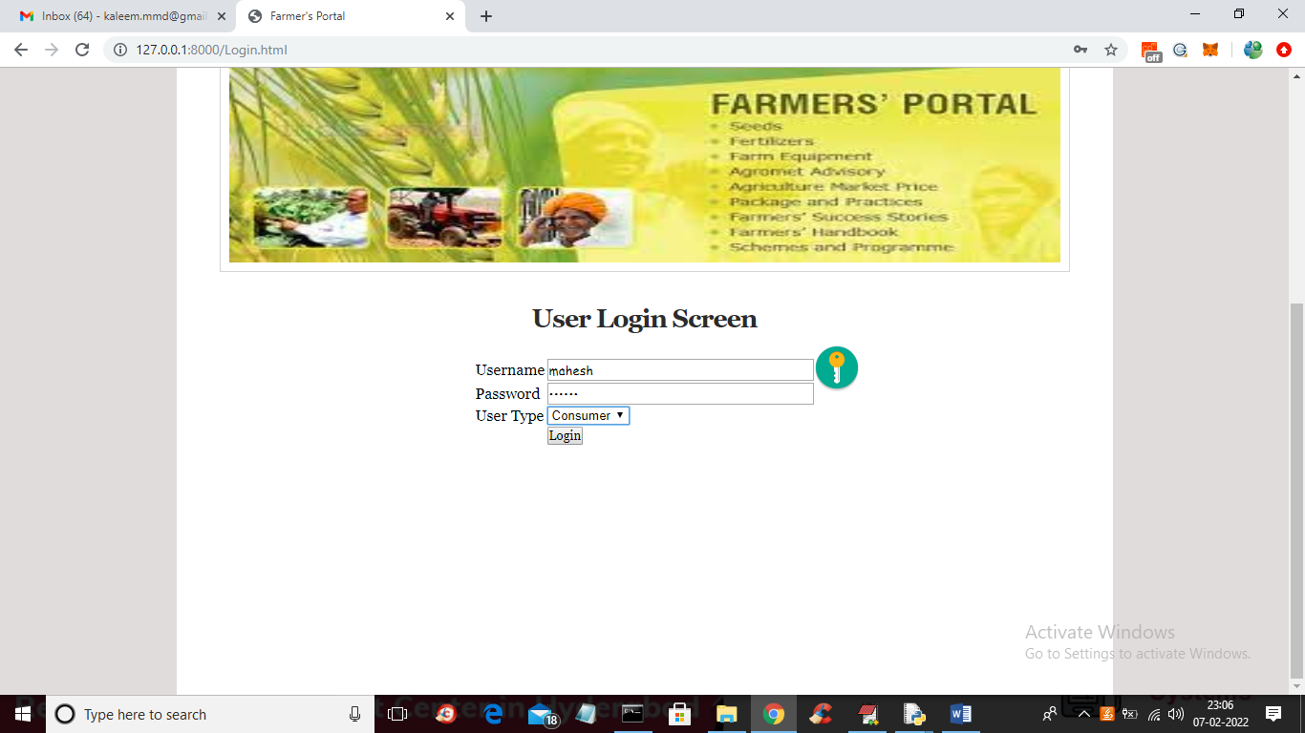

In above screen consumer is login and after login will get below screen

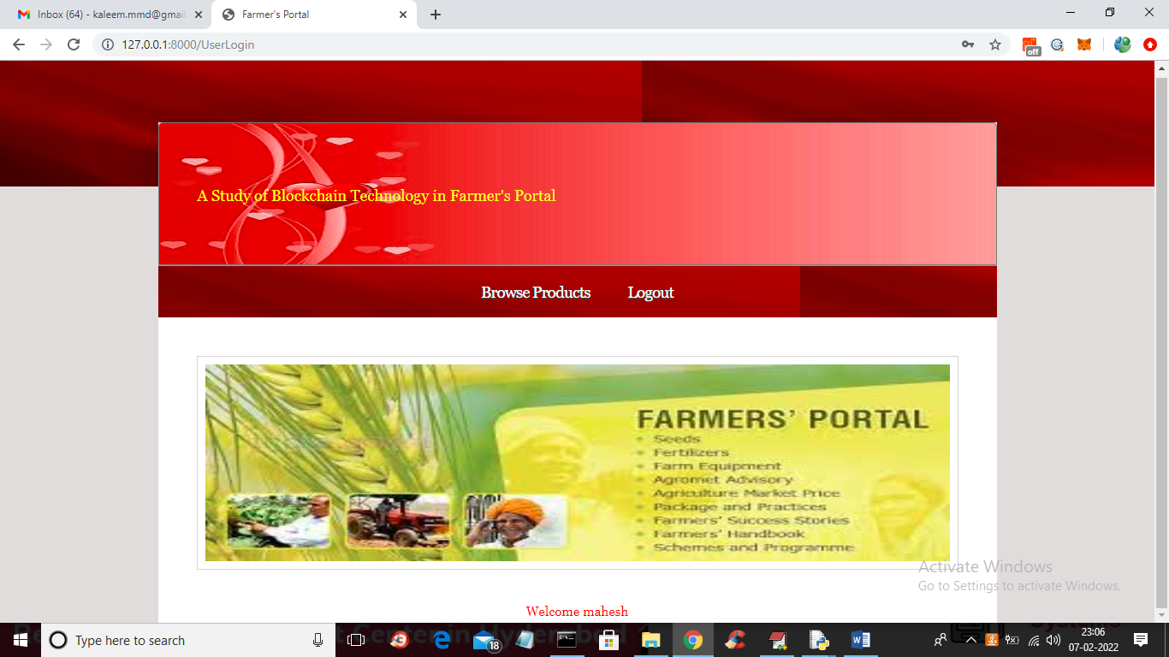

In above screen consumer can click on ‘Browse Products’ link to view list of products like below screen

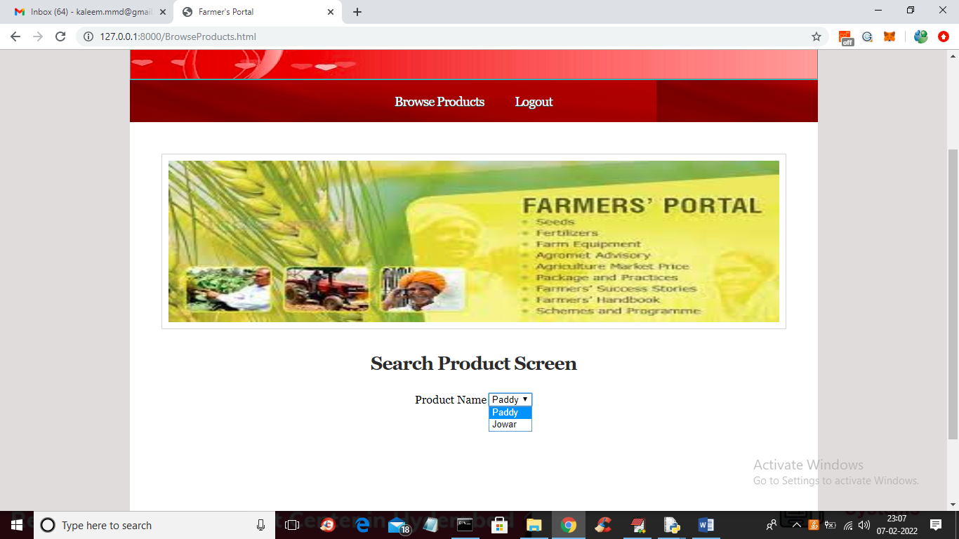

In above screen user can select desired crop and press button to get below screen

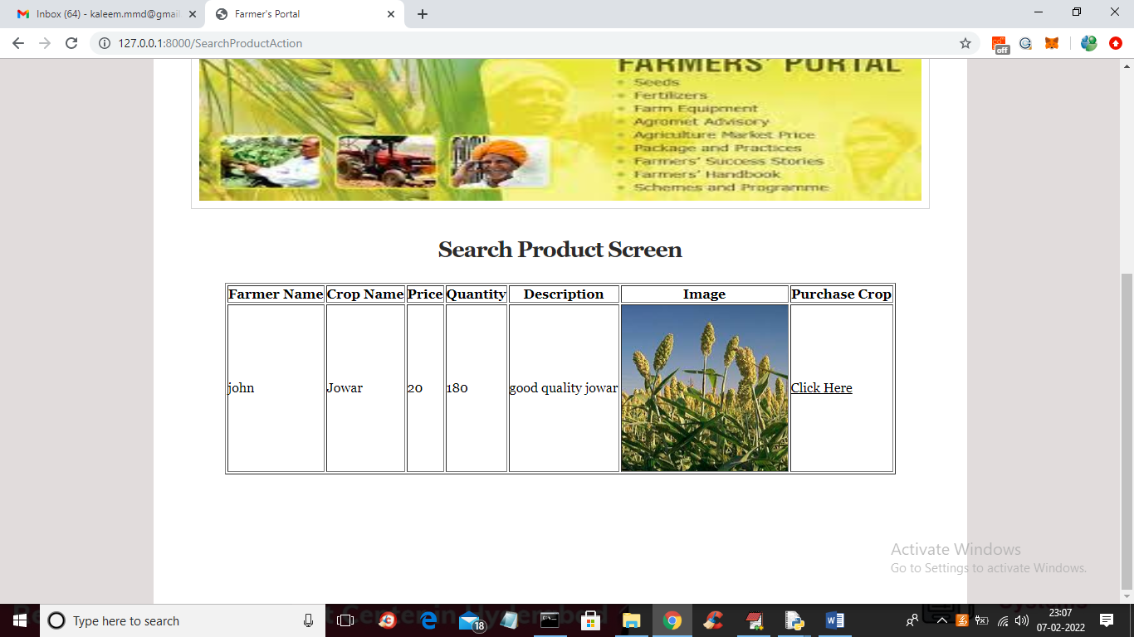

In above screen consumer can view crop details and then click on ‘Click Here’ link to book order and get below screen

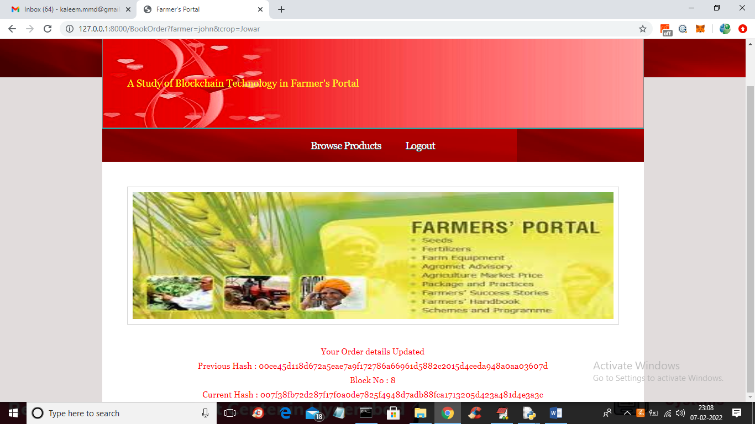

In above screen in red colour text we can see order details updated and now farmer can login and view and complete that order like below screen

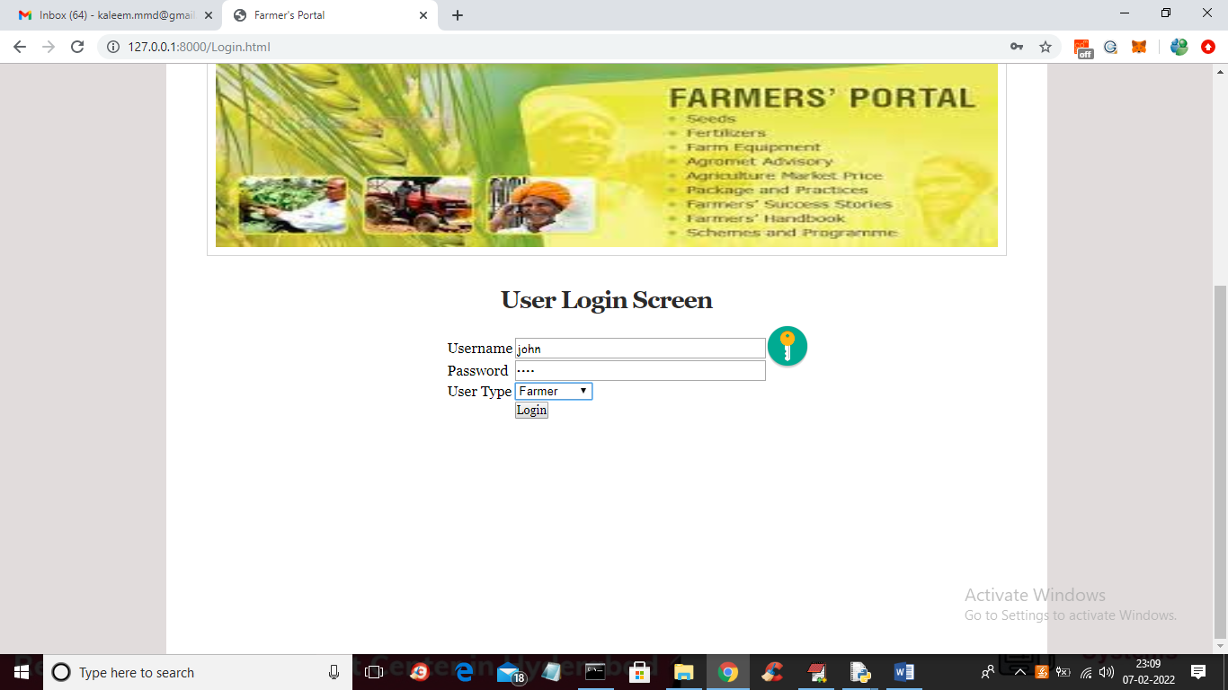

In above screen farmer is login and after login will get below screen

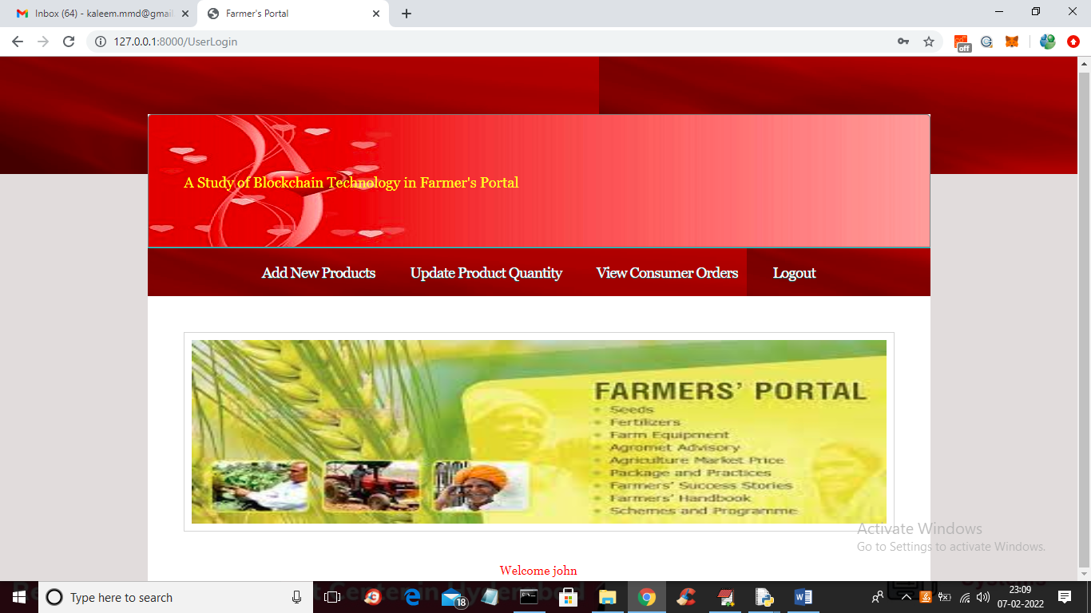

In above screen farmer can click on ‘View Consumer Order’ link to get below list of orders

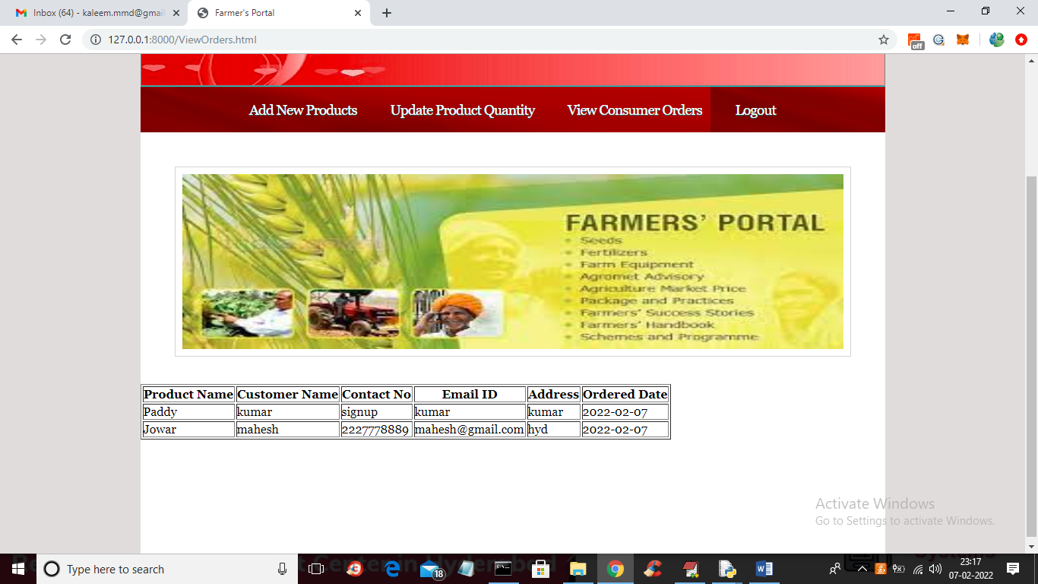

In above screen all farmers can view order details and then contact consumer to complete order.

Similarly you can add any number of farmers, consumers and add new crop details